SIMATS ENGINEERING

ASSESSMENT TOOL 3

COURSE NAME: Artificial Intelligence COURSE CODE: CSA1704

COURSE OUTCOME COVERED

CO5: Design AI-based systems using PySpark, RDD operations, and intelligent agent architectures, using scalable systems and integrate components in distributed AI applications. (BTL 5)
Assessment Tool Weightage: 20%

Duration : 1 Hour
QUESTIONS: 5 Total Marks:50

Annexure A

Reverse Engineering

Code of Conduct:

I Bhavya S(192524376) (Name / Reg No) certify that this submission is my original work and that I have adhered to the guidelines specified for this assessment.
I understand that any violation of academic integrity rules will result in disciplinary action.
Signature of the student: Bhavya S

REVERSE ENGINEERING – ACADEMIC COURSE OPTIMIZER
AI-Based Academic Course Recommendation and Curriculum Optimization System

System Decomposition & Analysis
The existing system is an AI-based Academic Course Recommendation and Curriculum Optimization System. Its purpose is to recommend and allocate suitable academic courses by considering student academic performance, interests, skills, career goals, preferences, merit ranking, and course capacity.
The major components are:
  - Admin Module – provides secure login, dashboard, course allocation management, department-wise statistics, course-wise allocation, and allocation reports.
  - Student Module – provides student login, profile information, course preference selection, preference ranking, allocation status, and timetable access.
  - Dataset Layer – contains course, department, staff, student, and timeslot data.
  - Allocation Engine – sorts students by CGPA and processes their course preferences.
  - Greedy Decision Module – selects the first available preferred course while considering seat capacity.
  - Reporting Module – produces allocation summaries including successfully allocated and unallocated students.
The main data flow is: Student/Course Data → Merit Sorting → Preference Checking → Greedy Allocation → Capacity Checking → Final Allocation → Reports/Student View.
The underlying decision-making method is a Greedy Algorithm. It selects the best currently available option for each student based on merit, preference priority, and seat availability.

Architecture Reconstruction
The reconstructed architecture consists of five logical layers.
  - User Layer: Admin and students access the system through their respective login interfaces.
  - Application Layer: Admin dashboard and student preference-management functions handle requests.
  - Data Layer: Student, course, department, staff, and timeslot datasets provide the required information.
  - Allocation Layer: The system sorts students according to CGPA, checks P1, P2, and P3 preferences, and applies the Greedy Algorithm.

  - Output Layer: The system produces course allocations, remaining-seat information, allocation statistics, reports, and student timetable information.
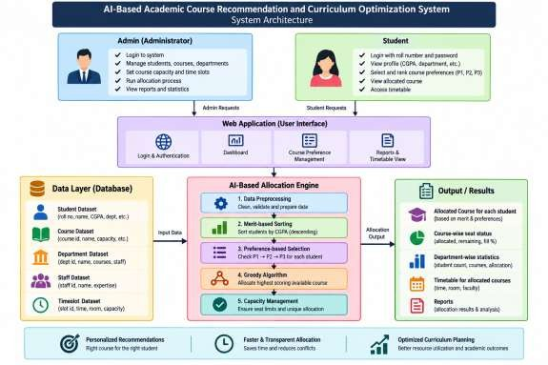
Interaction between modules:
Admin/Student → Login → Application Module → Dataset → Allocation Engine → Allocation Result → Dashboard/Student Portal.
During allocation, students are processed in descending CGPA order. For each student, the system checks the first preference. If seats are unavailable, it checks the next preference. Allocation stops for a course when its capacity is reached. Each student receives at most one course.

Algorithm Identification
The reverse-engineered application uses a Greedy Algorithm for course allocation. The processing steps are:
  - Collect student information such as CGPA, department, interests, skills, career goals, and preferences.
  - Collect course information including course availability and seat capacity.
  - Sort students by CGPA in descending order to establish merit-based allocation.
  - Read each student's course preferences in priority order: P1, P2, and P3.
  - Select the first preferred course that still has available seats.
  - If P1 is full, check P2; if P2 is full, check P3.

  - Stop allocation for a course when its capacity is reached.
  - Ensure that a student receives at most one course.
  - Generate the final allocation report.
The suitability decision is based on student characteristics and course preferences, while the allocation stage uses merit order and capacity constraints. The system is designed to provide fast decision-making and reduce manual course-selection effort.

Data Flow & Process Mapping
The system follows a structured data-processing pipeline. Input data:
- Student dataset – student identity, department, CGPA, and preference-related information.
- Course dataset – available courses and their capacities.
- Department dataset – department information.
- Staff dataset – staff information.
- Timeslot dataset – available time slots.

Processing flow:
Student/Course Data → Data Collection → CGPA-Based Merit Sorting → Preference Checking → Course Availability Check → Capacity Validation → Course Allocation → Allocation Report.
Student / Course / Department / Staff / Timeslot Data
↓
Data Preparation
↓
CGPA-Based Merit Sorting
↓
Preference Checking (P1 → P2 → P3)
↓
Course Availability & Capacity Check
↓
Greedy Course Allocation
↓
Seat/Allocation Update
↓
Final Allocation + Reports + Timetable
The system first receives student and course information. Students are arranged in descending CGPA order. The allocation engine then examines each student's preferences. The first available preferred course is selected. If the course is full, the next preference is

considered. Once a course reaches its capacity, further students are redirected to their next available preference.
The final output contains allocated students, unallocated students, course-wise allocation, remaining seats, fill percentage, department-wise statistics, and student allocation/timetable information.

Improvement & Redesign
The existing system can be improved to increase scalability, efficiency, transparency, and personalization.
  - Scalable Data Processing – For a large student population, distributed processing such as PySpark/RDD operations can be introduced to process student and course datasets efficiently.
  - Better Recommendation Model – The current Greedy approach can be extended with a hybrid recommendation model that combines academic performance, interests, skills, career goals, and historical course outcomes.
  - Skill-Gap Analysis – The system can identify missing skills or prerequisites and recommend courses that help students improve those areas.
  - Career and Industry Integration – Current industry skills and career opportunities can be connected to course recommendations.
  - Explainable Recommendations – The system can display why a particular course was recommended, improving transparency and student trust.
  - Personalized Learning Path – Recommendations can be extended from one course to a semester-wise learning plan.
  - Performance Monitoring – Accuracy, precision, recall, F1-score, response time, and scalability can be continuously evaluated.
The redesigned system would retain the existing merit, preference, and capacity rules while adding scalable processing and more personalized recommendation capabilities.

